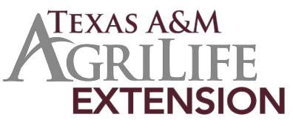
2019 Texas 4-H Fashion Show
Natural Fiber Entry Form

Name: Number of years in clothing project: Address: Phone number: City: State: Zip code: County: District: E-mail:

Category (check one): Cotton Wool/Mohair/Alpaca

Insert or glue a high-quality front and back view head-to-toe photo of participant in the competition garment in the space below. Photo/Photos should not exceed the space below.

Project Goals and Activities
What goals did you set for your Fashion & Interior Design project, specifically targeting Natural Fiber?

What project activities did you participate in to help you reach your goals?

What community service activities were you involved with?

Describe your leadership experiences within your Fashion & Interior Design project, specifically targeting Natural Fiber?

Knowledge of Fiber Characteristics
Identify fiber characteristics that are important in apparel.

Explain why the fiber selected is a good choice for your garment.

Describe the care requirements of the garment.

Identify the fiber content of the garment.

Promotion of Natural Fiber
Describe the fiber production process.

Describe how you have promoted the use of natural fibers.

Write a paragraph promoting your fiber.

I certify that I have read the 2019 Fashion Show/Natural Fiber guidelines and that my entry complies with the requirements.

Contestant’s Signature: Date Signed:

I have read this form and give permission for my child to participate in the Texas 4-H Fashion Show awards program. I certify that I have read the 2019 Fashion Show/Natural Fiber guidelines and that my child’s entry complies with the requirements.

Signature of Parent/Guardian: Date Signed:

I certify that the 4-H member whose signature appears above has been provided a copy of the 2019 Fashion Show/Natural Fiber guidelines and that he/she has completed a clothing project.

Signature of County Extension Agent responsible for the 4-H Clothing Program:

Date Signed:

2019
The members of Texas A&M AgriLife will provide equal opportunities in programs and activities, education, and employment to all
persons regardless of race, color, sex, religion, national origin, age, disability, genetic information, veteran status, sexual orientation or gender identity and will strive to achieve full and equal employment opportunity throughout Texas A&M AgriLife.

