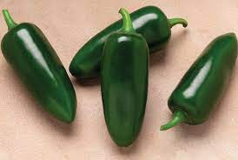
#1

What is the product above?
1. Okra
2. Jalapeño
3. Bell Pepper
4. Green Chile

This product is Rich in which of the following nutrients?
- Calcium
- Fiber
- Vitamin A
- Vitamin K
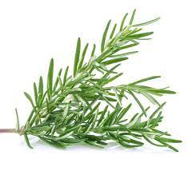
#2

What is the product above?
- Rosemary
- Basil
- Thyme
- Cilantro

This product grows best in…..?
- Slightly basic soil
- Very basic soil
- Very acidic soil
- Slightly acidic soil
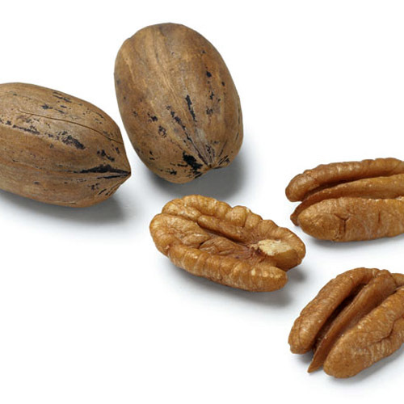
#4

What is the product above?
- Walnut
- Peanut
- Pecan
- Almond
How many commercial acres are grown in Texas?
- 50,000
- 70,000
- 90,000
- 100,000
#4
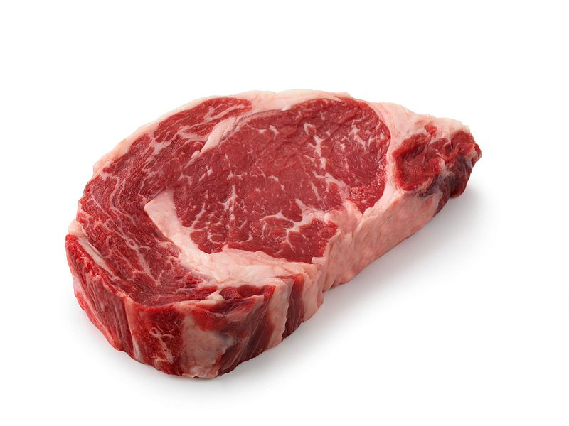
What is the product above?
- Back Ribs
- Porterhouse Steak
- T-Bone Steak
- Ribeye

What Primal Cut does this product come from?
- Chuck
- Rib
- Loin
- Round
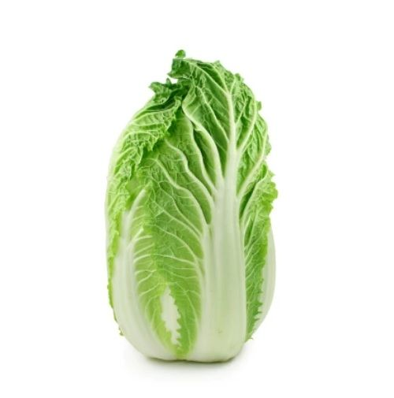
#5

What is the product above?
- Lettuce
- Celery
- Napa
- Cauliflower

What is the growing season in Texas?
- December - April
- May - July
- July - October
- June - November

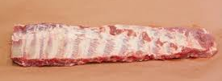
#6

What is the product above?
- Spare Ribs
- Loin Chop
- Bacon
- Ham
What Primal Cut does this product come from?
- Loin
- Side
- Leg
- Shoulder Butt

#7
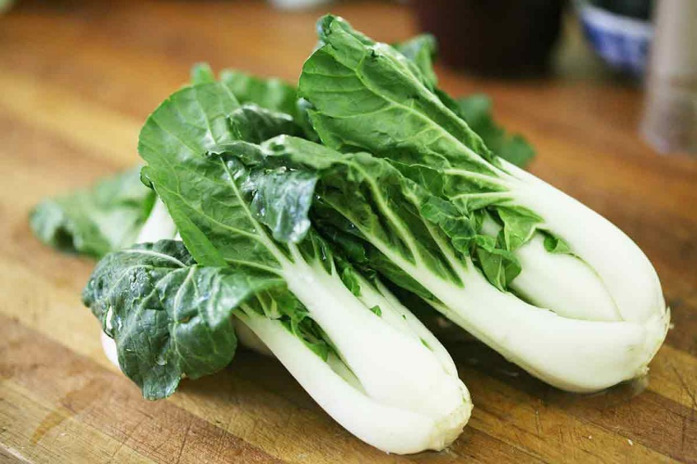

What is the product above?
- Lettuce
- Celery
- Napa
- Bockchoy
Humidity level to grow this product should be…
- 90 – 98%
- 80 - 88%
- 70 – 85%
- 90 – 105%

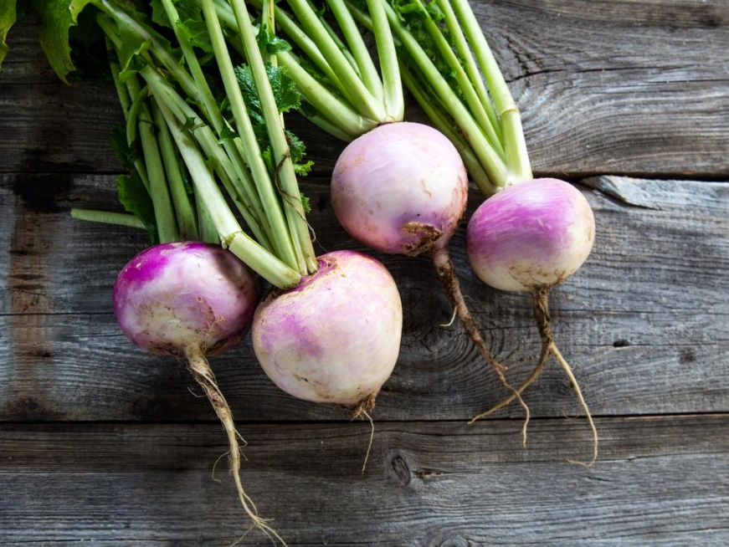
#8

What is the product above?
- Beat
- Radish
- Turnip
- Red Onion
How should this product be stored?
- Freezing temperatures
- Cold temperatures
- Warm temperatures
- Room temperature

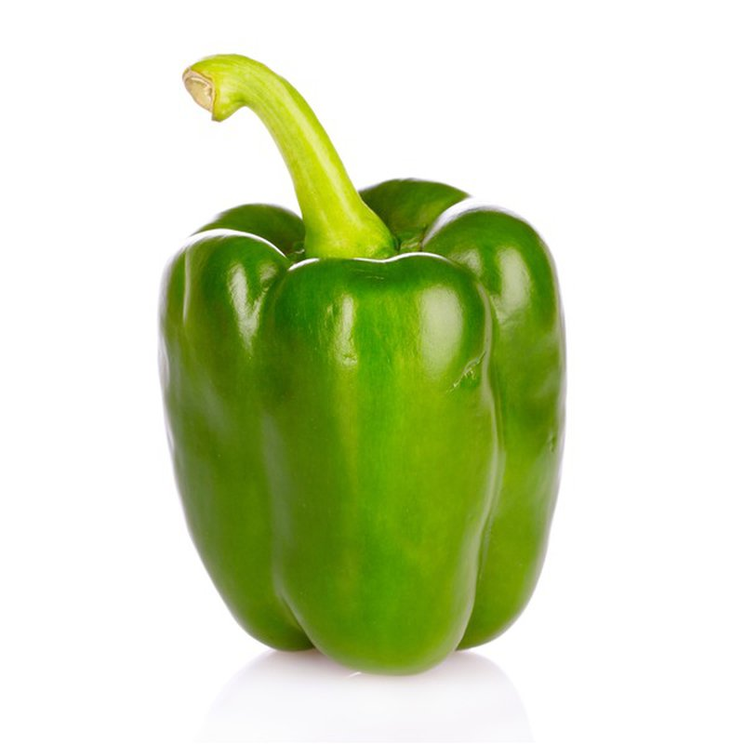
#9

What is the product above?
- Jalapeño
- Bell Pepper
- Green Chile
- Green Apple
This plant needs at least ___ hours of sunlight
- 2 hours
- 3 hours
- 5 hours
- 6 hours

#10
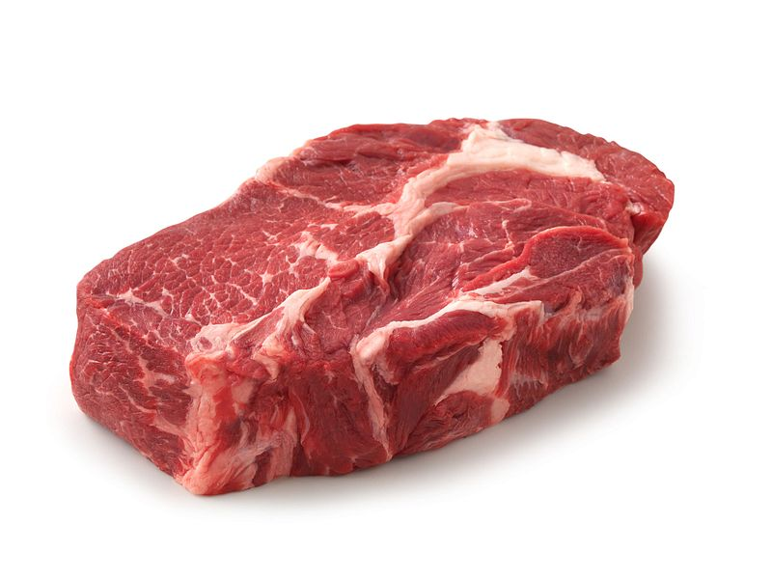
What is the product above?
- T-Bone
- Top Sirloin Steak
- Chuck Roast
- Skirt Steak
What Primal Cut does this product come from?
- Chuck
- Rib
- Loin
- Round

#11
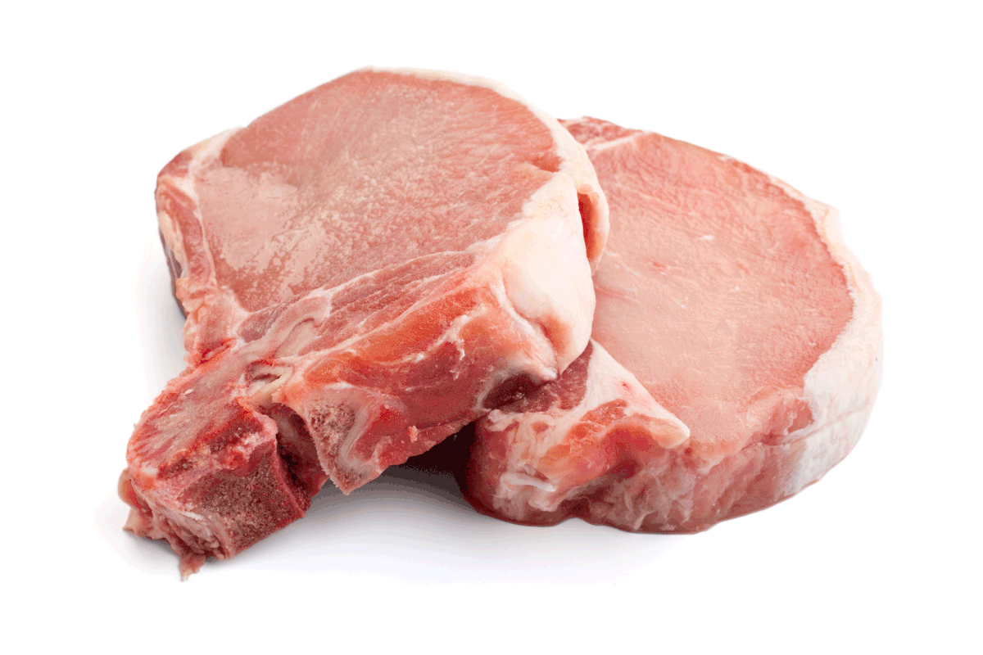

What is the product above?
- Smoked Hocks
- Boston Butt Roast
- Ham
- Loin Chop
What Primal Cut does this product come from?
- Leg
- Side
- Loin
- Picnic Shoulder

#12

What is the product above?
- Lettuce
- Celery
- Napa
- Bockchoy
Humidity level to grow this product should be…
- 90 – 98%
- 80 - 88%
- 70 – 85%
- 90 – 105%

#13

What is the product above?
- Lettuce
- Celery
- Napa
- Bockchoy
Humidity level to grow this product should be…
- 90 – 98%
- 80 - 88%
- 70 – 85%
- 90 – 105%

#14

What is the product above?
- Lettuce
- Celery
- Napa
- Bockchoy
Humidity level to grow this product should be…
- 90 – 98%
- 80 - 88%
- 70 – 85%
- 90 – 105%

#15

What is the product above?
- Lettuce
- Celery
- Napa
- Bockchoy
Humidity level to grow this product should be…
- 90 – 98%
- 80 - 88%
- 70 – 85%
- 90 – 105%

#16

What is the product above?
- Lettuce
- Celery
- Napa
- Bockchoy
Humidity level to grow this product should be…
- 90 – 98%
- 80 - 88%
- 70 – 85%
- 90 – 105%

#17

What is the product above?
- Lettuce
- Celery
- Napa
- Bockchoy
Humidity level to grow this product should be…
- 90 – 98%
- 80 - 88%
- 70 – 85%
- 90 – 105%

#18

What is the product above?
- Lettuce
- Celery
- Napa
- Bockchoy
Humidity level to grow this product should be…
- 90 – 98%
- 80 - 88%
- 70 – 85%
- 90 – 105%

#19

What is the product above?
- Lettuce
- Celery
- Napa
- Bockchoy
Humidity level to grow this product should be…
- 90 – 98%
- 80 - 88%
- 70 – 85%
- 90 – 105%

#20

What is the product above?
- Lettuce
- Celery
- Napa
- Bockchoy
Humidity level to grow this product should be…
- 90 – 98%
- 80 - 88%
- 70 – 85%
- 90 – 105%

